GEO EnVison Name:

10.2 Tangent Practice Date: Period:

1.) Rays m and n are tangent to circle P 2.) Rays r and s are tangent to circle Q.

*w* =  *x* =

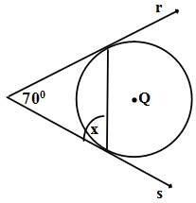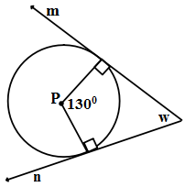

3.) Ray k is tangent to circle R. 4.) Line t is tangent to both 5.) Quadrilateral POST is

*y* = tangent circles. *z* = circumscribed about circle Y. OR = 13in and ST = 12in. Find the perimeter of POST.

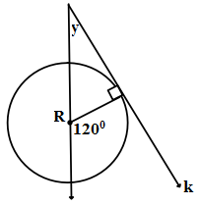

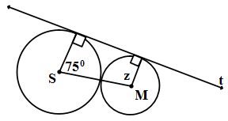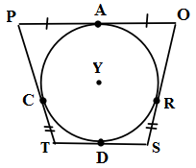

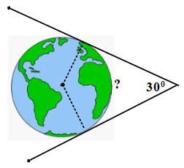6.) A satellite in geostationary orbit remains above the same point on Earth’s surface even as Earth turns. If such a satellite has a view of the equator, what percentage of the equator is observable from the satellite?