DG Unit 10 Review Name:

Date: Period:

Show all your work and round answers to the nearest hundredth

In Exercises 1-3, find each unknown or write “cannot be determined.”

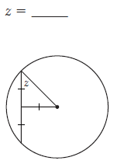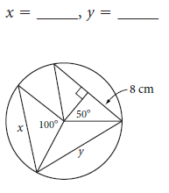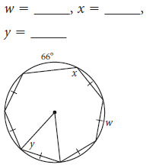

**1.) 2.) 3.)**

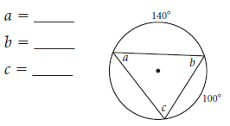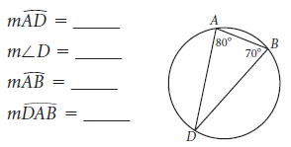

**4.)** **5.)**

**6.)**  x = **7.)** Is TP a tangent? Show your work.

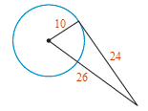

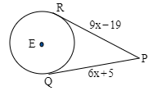

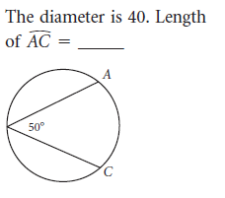

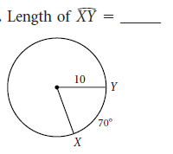**8.)** **9.)**

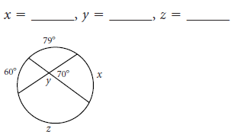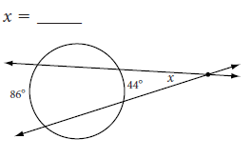**10.) 11.)**

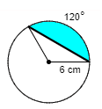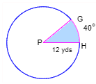**Find the area of the shaded region for #12 – 23…show all work.**

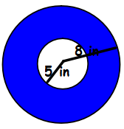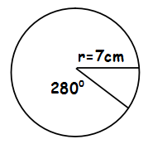**12.) 13.) 14.) 15.)**

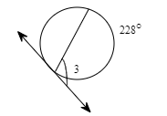**16.)** Find each indicated measure for circle O. 17.) Find

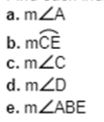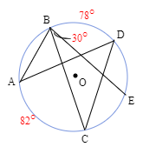

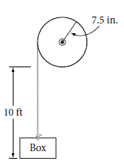**18.)** To use the machine at right, you turn the crank, which turns the pulley wheel, which winds the rope and lifts the box. Through how many rotations much you turn the crank to lift the box 10 feet?

**19.)** An athletic field is 60yd by 120yd rectangle, with a semicircle at each of the short sides. A running track 20yd wide surrounds the field. If the track is divided into eight lanes of equal width, with lane 1 being the inner-most and lane 8 being the outer-most lane, what is the distance around the track along the inside edge of each lane?

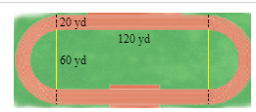

**20.)** Prove the following:

If two arcs in a circle are congruent, then their cords are congruent. (Hint: Draw in radii)

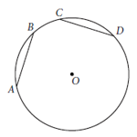Given:

Prove: