GEO EnVision Name:

10.3 Chords Review Date: Period:

Solve exercises 1-10. State which theorem or definition used to find the solution. (Pictures not drawn to scale)

1.) x = 2.) z = 3.) w = 4.) AB = CD

PO = 8cm

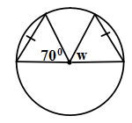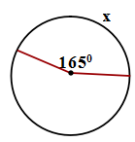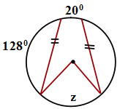 OQ =

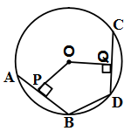

5.) Find 6.) GIAN is a kite. 7.) AB = 6cm OP = 4cm Find w, x, and y. CD = 8cm OQ = 3cm

BD = 6cm What is the perimeter of OPBDQ?

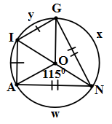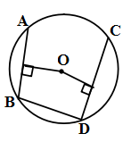

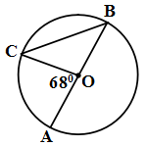

8.) 9.) x = 10.)

Find w, x, y, and z y = Find x, y, and z.

z =

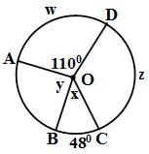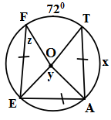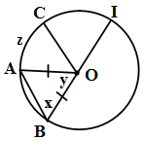

For exercises 11-12, describe what is wrong with the following pictures.

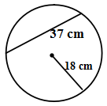

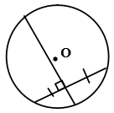11.) 12.)