enVision Geometry Name:

10.5 Review Date: Period:

1.) Find the value of each variable.

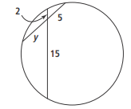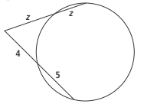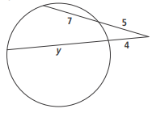 a.) b.) c.)

2.) Find each angle measure.

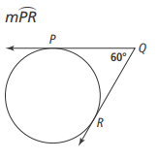

a.) 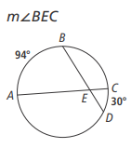 b.)

3.) HJ is tangent to the circle for a(a) . Find each length.

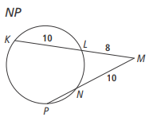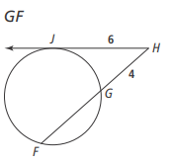 a.) b.)

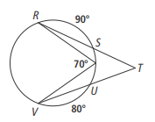4.) What is the measure of ?

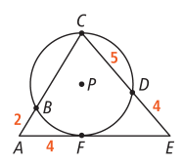5.) AE is tangent to circle P. find each length.

a.) BC

b.) EF

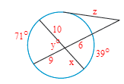6.) Find the missing variables.

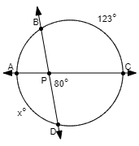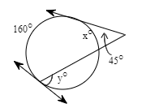

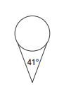

7.) The diagram shows an ice cream cone with a spherical scoop of ice cream on top. The cone is tangent to the ice cream scoop. What percentage of the circumference of the ice cream is inside the cone? Round to the nearest tenth of a percent.

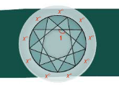

8.) Carolina wants to etch the design shown onto a circular piece of glass. At what measure should she cut? Explain.

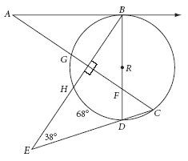

9.) is tangent to circle *R*, , *m*∠*BED =* 38°, and .

**a.** *m*∠*EBD* **=** _______ **b.** *m*∠*ACE =* _______ **c. =** _______

**d. =** ________ **e.** *m*∠*DBA =* _______ **f. =**_______

**g.** *m*∠*DFC =* ________